

**fashion trends-image classification and deep learning techniques**

**Done By-Meghana B. L**



FASHION TRENDS - IMAGE CLASSIFICATION AND DEEP LEARNING TECHNIQUES

Dissertation submitted in partial fulfillment of the requirements for the degree of

MSc Data Analytics

At Dublin Business School

B.L. Meghana

(10386493)

MSc Data Analytics 2019-20

Declaration:

I, B.L. Meghana, declare that this research is my unique work and that it has never been presented to any institution or university for the award of Degree or Diploma. In addition, I have referenced correctly all literature and sources used in this work and this work is fully compliant with the Dublin Business School’s academic honesty policy.

Date: 26-08-2019

Acknowledgment:

Firstly, I might want to offer my true thanks to my supervisor Terri Haore for the persistent help of my master's study and research, for her understanding, inspiration, eagerness, and monstrous learning. Her direction helped me in all the season of research. The patience level she carries out immensely and solves the doubts in a very keen manner is appreciable. I couldn't have envisioned having a superior counsel and supervisor for my thesis. Huge gratitude to Ms. Terri haore for being with me in all the steps of my research work.

I also thank my parents for their constant support and encouragement towards my master's.

**ABSTRACT:**

*Fashion-Trends gives a brief knowledge about how we have proposed a best in class model for classification of fashion images. The global fashion industry is valid until three trillion-dollar years and accounts for 2% of the World’s GDP. From the past few years, the fashion industry has reached its peak by adopting computer vision by using machine learning and deep learning techniques and people using e-commerce websites for buying these fashionable things have increased drastically. The simulated assistant can help the retailer to detect what clothes the customers are wearing and classify according to them. Here, in this research paper, we have mainly focused on the performance of state-of-the-art traditional algorithms with H2O implemented deep learning algorithms using RapidMiner, a leading data science platform. The implementation of the classifier using Python Flask to test classification on its image garment samples. Overall, the deep learning will outpace traditional process with the optimal performance achieved using the Python Keras model.*

**Table of contents**

|  |  |  |
| --- | --- | --- |
| Chapter No. | Title | Page No. |
|  | **Declaration** | 2 |
|  | **Acknowledgements** | 3 |
|  | **Abstract** | 4 |
|  | **List of Figures** | 6 |
|  | **List of Tables** | 7 |
| 1 | **Introduction** | 8 |
|  | 1.1 Background | 8 |
|  | 1.1.1 Discussion about the fashion industry | 9 |
|  | 1.2 Concept exploration | 10 |
|  | 1.3 The present research  1.4 Scope  1.5 Hypothesis  1.6 Limitations | 11-12 |
| 2 | **Literature review** | 13 |
|  | 2.1 Introduction | 13 |
|  | 2.2 Background | 13-18 |
|  | 2.3 Related works | 18-19 |
| 3 | **Research Methodology and Methods** | 20-32 |
| 4 | **Model Result & Discussion** | 33-42 |
|  | 4.1 Comparison of the Algorithms | 33-42 |
| 5 | **Conclusions and future work** | 43-44 |
| 6 | **Referencing** | 45-51 |
| 7 | **Appendices** | 51-52 |

# List of figures

|  |  |  |
| --- | --- | --- |
| Figure  No. | Title | Page No. |
| 1.1 | Dissertation Roadmap | 12 |
| 3.1 | CRISP-DM Methodology | 20 |
| 3.2 | Fashion MNIST Dataset | 23 |
| 3.3 | Data Preparation of Dataset | 24 |
| 3.4 | Convolution Neural Network | 26 |
| 3.5 | Working of Logistic Regression | 28 |
| 3.6 | Architecture of Deep Learning | 29 |
| 4.1 | Grid performance of a classification model | 33 |
| 4.2 | Confusion Matrix | 34 |
| 4.3 | Evaluation of Model | 35 |
| 4.4 | Confusion Matrix Deep Learning | 37 |
| 4.5 | Confusion Matrix Logistic Regression | 37 |
| 4.6-4.7 | Confusion Matrix GLM & Naïve Bayes | 38 |
| 4.8 | Confusion Matrix Random Forest | 39 |
| 4.9 | Confusion Matrix SVM | 40 |
| 4.10.-4.11 | Prediction of fashion-model image | 41- |

**List of Tables**

|  |  |  |
| --- | --- | --- |
| Table  No. | Title | Page No. |
| 4.1 | Model Result in Rapid Miner | 35 |
|  |  |  |

**List of Algorithms**

|  |
| --- |
| ALGORITHMS |
| Convolutional Neural Networks |
| Naïve Bayes  Support vector machine  Deep Learning  Logistic regression  Generalised Linear Model  Random Forest |

**Chapter 1: Introduction**

***“Fashion is a piece of the everyday air and it changes constantly, with every one of the occasions. You can even observe the drawing nearer of an insurgency in garments. You can see and feel everything about clothes.”***

***-------- Diana Vreeland***

(“50 Famous Quotes from Fashion Icons - Famous Fashion Quotes From Designers,” n.d.)

## 1.1 Background:

The deep learning method has become an important technique for using artificial intelligence. This is a part of the technique of machine learning in which the algorithms are used for learning and analyzing the images and texts. With the help of the computing power, deep learning technique helps in the reorganization of the patterns of the images and thus provides significant results. This technique uses the architectures of the neural networks to generate meaningful results. In the fashion industry, the use of deep learning technology has become a popular choice. With the help of the deep learning techniques, the patterns in the images of the clothing are assessed and further the datasets are used to analyze the results of the deep learning methods. With the help of the deep learning techniques, the retailers can classify all the garments according to the style and textures. Manual classification in this regard is an extremely difficult task to do. Therefore; with the help of the image classification techniques in deep learning methods, users can assess different images and therefore; the classifications can be made with ease. This process is helping significantly improving services in the fashion industry. The deep learning techniques use the Convolution Neural Networks in the process of classifying the images of the Fashion-MNIST dataset(Li et al., n.d.)The classification of the images is an extremely difficult task to do by using the computer algorithm. This is because; the accuracy may not be achieved with perfection. In this regard, algorithms of the deep neural network help significantly to derive the required accuracy. This is why deep learning methods are now being widely used in the process of image classification. By using the Convolution neural network or CNN, the images get automatically classified which helps the fashion industries to divide or classify those according to the style and texture(Shah and Hanchate, 2018). Therefore; rather than using machine learning methods or the computer algorithms, the fashion industry is now preferring to use deep learning algorithms to conduct image classification with efficiency.

### 1.1.1 Discussion about the fashion industry:

The fashion industry has gained huge popularity in recent years around the world. With the innovation on a different design of the garments for men, women, and kids, the competition in this industry has also increased significantly. The fashion industry is now aiming for further innovation in the aspect of manufacturing quality and unique design of garment products (T.L. Chan et al., 2016). It is difficult for the fashion industry to understand the different requirements of the products and to select the quality dresses from the manufacturers of the garments industry. This is because; most of the organizations of the fashion industry stock the garment products which are most suitable for their target customers. Along with this, with the mass production of the garments, it is also difficult for the manufacturers of the garment products to categorize the clothes according to their color, sizes, and textures. In this regard, deep learning techniques help significantly in identifying these attributes and help the organizations of the fashion industry to automatically classify these different patterns of the dresses with ease.

By using deep learning techniques, these fashion designers can identify the patterns of dresses to be designed according to different colors, textures, and sizes. If the classification of these colors and textures is done automatically, then the task for the fashion designers becomes easier. This is because; the manual process of selecting suitable textures, colors, and sizes of garments is a challenging task. The challenges come from the fact that this process takes a long time to complete along with having a huge possibility of error. In this regard, deep learning techniques bring in the accuracy of the classification of the images of the garments. This is because the overall process is completed in real-time and this brings down the time required to complete the task of classification and identification. Therefore; for the fashion industry, use of the deep learning technology has become a favorable option for bringing in innovation in terms of designing attractive and unique garments for the customers with efficiency. In this regard, the benefits of image classification through deep learning methods are going to be extremely purposeful. If further development is made in this technology, then the benefits would increase significantly and will bring in evolution in the fashion industry. In this research, there will be a detailed analysis of the techniques of the deep learning method and how these techniques can be utilized perfectly by the fashion industry to bring in innovations.

## 1.2 Concept exploration:

In the case of image classification, the data set is pre-processed and the different categories of the dataset are assessed. For example, different garments of different colors and sizes are divided into different images. Each of the types of garments is considered as different categories. These categories form a specific dataset that is further used for the classification. Then different samples of the categories get classified with the help of CNN and further¸ the data set is divided into a training set, test set, and verification set. Then, at last, the images are classified according to their features and thus, CNN becomes extremely important to provide the retailers of the fashion industry with the accurate results of the classification. The accuracy, in this case, is higher than other algorithms and thus, the result of the classification becomes almost perfect one. In the case of extraction of the physical edges of the garments, Deep Convolutional Neural Network is used. With this method, the physical edges are classified pixel-wise and thus, the accuracy becomes higher(Xie and Tu, n.d.)**.** This process is also helpful for the real-time recognition of the classified images and thus the retailers of the fashion industry get hugely benefited by using this technique. A method of systematic color segmentation is used in the process of classifying the garments according to the colors. In the case of the manual works, the method of classification is high time taking and the possibility of high accuracy is always lower. In this regard, CNN helps the fashion industry to conduct the task of classification automatically and with ease. In recent years, the classification of garments based on the textures is getting highly popular. Local Binary Pattern or LBP is a popular method of classification of garments according to their textures. In this process, the computation process is a simple one and thus is widely used for classifications of the images of garments (Islam et al., 2017). AlexNet model and VGGNet model are the two of the renowned models which are used for the process of image classification and are extremely beneficial. In the case of CNN, the input images are taken by filtering the patterns of the images. This process helps in analyzing the accurate pattern, which in turn helps in enhancing the accuracy of the result with success. Therefore; CNN is the most preferred model and technique of image classification that is used widely in the garments industry. Along with this, deep learning techniques are now getting advanced to provide better results and would further continuous improvement in the future as well.

## 1.3 The present research:

In the case of using deep learning methods, texture-based synthesis is also used which helps in assessing the fundamental texture of the images in the process of creation of the new samples**.** Therefore; research can be done on all these processes of image classification. (Xian et al., 2018)

The present research will be based on the techniques and methods by which image classification is done with the help of the deep learning methods. The benefits and the limitations of this method will be assessed through this research as well. Along with this, there will be discussions on how the algorithms of a convolution neural network can be utilized with perfection in the process of image classification in the fashion industry. The use of traditional machine learning algorithms has played a major role in this research. The use of datasets and the patterns of image classification will be also researched with the help of the relevant data. Secondary resources will be used to collect user data and further those data will be analyzed with the help of proper research methodologies. The techniques of the methodology will be provided in this paper and the findings will discuss the overall result of the analysis.

# Research Question:

Comparison of the performance of traditional machine learning and state of the art deep learning algorithms for image classification.

**Research problem:** Using supervised learning traditional and deep learning techniques to classify fashion garments.

**Aim:**  Increase classifier performance in the identification of fashion garments.

**Objective:** To compare the performance of state-of-the-art traditional algorithms with H2O implemented deep learning algorithms using RapidMiner, a leading data science platform. Use Python, Tensorflow Keras CNN, to build a classifier to improve on performance accuracy. Implement the classifier using Python Flask to test classification on its image garment samples.

**Hypothesis:** Deep learning will outperform traditional methods with the optimal performance achieved using the Python Keras model.

**1.4 Scope:** The open-source fashion MNIST dataset was used for this research. Traditional algorithms tested on RapidMiner includes Deep learning, Support vector machine, Naïve Bayes, Decision trees, Logistic regression, Linear regression.

**1.5 Limitations:** Limitations Specifications of the laptop where it was 8 GB RAM and the processor was i5 8th generation- . The size of the dataset was also a limitation - fashion MNIST dataset (60000 training examples 10000 testing examples). While it is understood that deep learning performs better on larger datasets, it was nevertheless possible with this dataset on the laptop hardware to benchmark deep learning algorithms against traditional algorithms.

# Dissertation Roadmap:

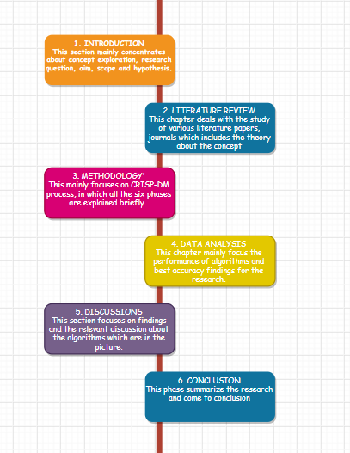

Figure 1.1: Dissertation Roadmap

# Chapter 2: Literature review

## 2.1 Introduction:

This chapter will highlight the secondary data that have been used to generate relevant theories behind the use of deep learning techniques for the image classifications in the fashion industry. The fashion trends in using deep learning techniques in the aspect of image classification will be also analyzed through secondary resources. The data will be based on the information that the articles provided and the information will be critically analyzed to find the results. In this regard, the process of image classification and its benefits for the fashion industry will be also assessed through this chapter.

## 2.2 Background:

Authors (Lin et al., 2015) discussed the process of retrieval of the clothes by using the image classification methods. In this process, binary codes are used along with conducting the hierarchical searches to retrieve the images of different garments. This process is a rapid one and helps in generating the classification of the different sections of garments. Authors (Tuinhof et al., 2019)highlighted the benefits of image classification methods for recommendations of fashion clothes. In this process, deep learning techniques are used and the identification of the suitable garments is made by classifying those according to the requirements of the customers. This process is extremely beneficial in terms of arranging the garments according to the requirements of different groups of customers. On the other hand authors,(Corona et al., 2018)provided an analysis of the techniques by which the process of garment recognition can be enhanced with the help of image classification in deep learning techniques. In this process, the probability of the accuracy of the data is high and this helps the stakeholders of the fashion industry to classify and recognize various types of garments with success.

The use of CNN in the fashion industry is also known as deep fashion and this process is gaining huge popularity all over (Liu et al., 2016). This is because; with this process, the recognition of robust clothes is powered and can be recognized with ease. The other techniques generally fail to provide accurate results and for this, CNN is now widely accepted in the fashion industry. Authors (Tangseng et al., 2017)discussed the contribution of CNN in the process of parsing of the garments. In this method, the classification is made by breaking the images into pixels and further, the recognition is made by assessing the texture, colors, and structure of the images of the clothes. This is an extremely important and efficient process that is possible only with the help of deep learning techniques. The technique is also useful for conducting the image classification for a large data set of different patterns of clothes. This process is beneficial especially for the large organizations in the fashion industry which deal with a large set of garments and have a large number of customers to handle. The overall process of garments recognition and classifications become easier for them to implement

Authors Ganeshan and Oates(Date et al., 2017) discussed how the process of image classification is extremely beneficial for designing clothes in the fashion industry. This is possible with the help of proper image recognition and by understanding the patterns and texture to be used for different types of clothes and different groups of customers. Therefore; in the fashion industry, image classification does not only help in recognition of the garments rather it also helps in designing the garments as well. In this regard, deep learning techniques contribute significantly to the growth of the fashion industry. In the process of fashion classification as well as object detection, deep learning has become the most preferred technique and with this technique, the fashion industry is able to understand the importance of the patterns and textures of the garments and likewise, this is helping the industry to design attractive garments which are suitable different segments of customers(Hara et al., 2016). Therefore; the techniques of deep learning are becoming favorable for the fashion industry and the way it is helping the industry to design attractive clothes is helping it to grow significantly. Authors (Gupta, 2015)highlighted that along with a classification of the patterns and textures of garments, deep learning technology is also helping the industry to receive proper recognition on choosing the right garments for the specific groups of customers. This is benefiting the companies of the fashion industry as well as their customers. This is because; the customers are even getting the option of not wasting their time and are depending on the organizations or the designers to provide them with the garments that would suit their needs. The process is getting highly beneficial and would help in the significant growth of the fashion industry in the future.

## 2.2.1 Image classification in the fashion industry:

Authors (Al-Halah et al., 2017)provided analysis of the visual style that is being used for the fashion industry. The analysis is about the implementation of the visual style through image visualization, assessment of the images of the garments and further classification of the images. The process of using visual has been extremely impactful for the growth of the fashion industry around the world. Authors(Sun et al., 2017) provided a discussion about the impact of deep convolutional neural networks in the process of enhancing the process of image classification in the fashion industry. The benefit is in the form of the accuracy that the technique provides for image classification. The accuracy of the data increases the success of the fashion industry in terms of identifying the collections of garment products according to their categories. Authors(Li et al., 2017)provided analysis about the contribution of deep learning for the fashion industry. Due to this, it has been possible to initiate the fashion mining process. In terms of fashion mining, the fashion industry extracts the useful data that are available for this industry and with these data, it is possible for the industry to analyze the patterns of the demands and preferences of the customers for choosing their garments. Therefore; image classification is also a type of fashion mining which matches the particular images with the other similar images and provides the result of the analysis.

Authors(Wu et al., 2015) highlighted the process of a deep image in which the deep patterns and structure of the images are extracted and analyzed. In the process of image classification in the fashion industry, the classification of the deep images is only possible with the help of the deep learning technique. This is because the neural network algorithms are used which make use of the thinking of the human brain and automatically conducts the classification even for the bulk amount of images of the garments. This process significantly reduces the manual efforts and thus, enhances the ease of working in the fashion industry. Authors (Ngo et al., 2017)discussed user the importance of image classification in the process of ensuring the sustainability of the organizations in the fashion industry. The importance is in regard to the development of the strategies on customer service which is enhanced if the classification of the garments can be made in terms of colors and textures. In this process, the organizations of the garments industry would be able to understand the requirements of the customers and simultaneously would be able to deliver them with the exact choices of products without delay or error. Therefore; the sustainability of the fashion industry is going to be highly impacted in the future with the use of deep learning technology and its tools.

According to authors Piras and Giacinto (2017), the use of CNN for image classification has become an interesting field of research in computer vision. This is because; with the use of CNN, the process of image classification has become easier and this is contributing to the success of many industries. For the fashion industry, this interest can become highly beneficial in the future as well. This is because; more the researchers will show interest for CNN in image classification, there will be more scope of innovation and improvement in this field. The innovation and improvement in the aspect of CNN can become extremely significant for the development and growth of the fashion industry as well.

Authors (Zintgraf et al., 2017)Wellingdiscussed the advancement in the field of data visualization. The advancement has contributed to the development of deep learning and for this, the benefits of CNN has also increased significantly. The overall benefit in the field of data visualization is contributing significantly to the increasing benefits of deep learning techniques for image classification in the fashion industry. If this would be a continuous process, then there will be a huge scope for the fashion industry to improve its customer satisfaction as well.

### 2.2.2 Analysis on the image classification through deep learning techniques:

Authors (Wang et al., 2017)discussed the possibility of image augmentation with the help of deep learning techniques. In this regard, the data classification can be conducted by rotating or flipping the images. With these scopes, image classification can be done efficiently. Along with this, image augmentation also helps in the analysis of the images through different angles. This way, the patterns, and textures can be identified with ease. Therefore; this is one of the reasons why deep learning technique is a highly beneficial method that is used for image classification with efficiency. According to author (Chollet, 2017)highlighted the contribution of deep learning for going deep into the patterns of the images and then extracting the useful data for the fashion industry. Since the analysis is conducted through deep identification and therefore; the classification becomes a highly successful and accurate one. This benefits the fashion industry significantly. Image classification with deep learning is the most advanced process by which the fashion industry can identify the patterns of the images efficiently and with success.Authors(Rostamzadeh et al., 2018)discussed the forward fashion which has been only possible with the help of image classification. In this aspect, the presence of the fashion dataset has contributed to the ease of image classification. Along with this, it has been also possible to eliminate the errors and the prevailing challenges that were present until now in the process of data classification. This has been possible only with the use of deep learning techniques. The image to image translation is also now possible with the use of deep learning techniques and in this process; the images are translated into the datasets which are further used for identification of various patterns.Authors (Wu et al., 2015)highlighted the importance of scaling in the aspect of image recognition. The process of scaling helps significantly on resizing the images and for understanding the patterns from various sides and sets. Thus, with the use of deep learning techniques, the process of image scaling also gets enhanced and thus, becomes an extremely important process in the aspect of image classification for the fashion industry. Image scaling is also helping in understanding the patterns of the images of the garments with efficiency and resulting in the accuracy of the data. The perfection in the aspect of image classification is only possible with the use of efficient technique along with using the algorithms which can help in conducting a deep analysis of the pixels of the images. The images are thus broken down into pixels and each of these pixels is further assessed with deep analysis. The result of the analysis helps in deriving the categories of the images after proper classification.

Authors(Zintgraf et al., 2017)provided a discussion about the methods by which visualization of data can be increased. In this regard, with the deep analysis of the textures of the images, the process of data visualization gets improved significantly. Along with this, it also becomes possible to improve the aspect of data classification with success. In this regard, the decision-making process also becomes easier as it is possible to assess the quality and the pattern of the data without any kind of error. Therefore; according to the perception of the authors, the improvement of data visualization has been possible only with the improvement in the techniques of deep learning. The fashion industry is getting hugely benefited with the improvement in the field of data visualization.

Author (Marcus, 2018)provided analysis of the techniques of deep learning and analyzed that in terms of identification of the images with perfection, deep learning has become the most favorable technique of the data visualization. The algorithms that are used in deep learning help in assessing the patterns of the images by breaking the textures into pixels. This process helps in the identification of each of the features of those images with efficiency. The algorithms also help in establishing the different patterns and categories which are further matched with the test data and then the final result is evaluated. In this way, the fashion industry is getting highly benefited and each of the images is now evaluated with perfection to provide accurate results to the stakeholders.

Authors (Hohman et al., 2018)discussed visual analytics with the help of deep learning. According to their views, visual analytics help in analyzing the pattern of the images or videos automatically and thus, important decisions can be made based on the result of the analysis. This is the reason why the fashion industry is getting significant help in terms of making important decisions for meeting the level of satisfaction of the customers. In terms of using the visual analytics for image classification of the garments, the focus is always on matching the data pattern with the test data. In this regard, normal computer algorithms are not efficient enough to extract the exact ranges of the data sets. Moreover; the probability of accuracy of image classification is also very low. Therefore; it is important to use deep learning algorithms. This is because; the deep learning algorithms help in classifying the images which require deep analysis. The process of deep analysis is only possible with the help of deep learning techniques. In the aspect of using the process of visual analysis, deep learning technique is the most impactful and efficient one that is now widely used in the fashion industry.

### 2.2.3 Challenges of using image classification with deep learning techniques in the fashion industry:

Many challenges can arise in the process of using deep learning techniques in the fashion industry. According to authors (Vidgen et al., 2017), the challenges of data visualization come in terms of its usage. This is because; all the organizations of the fashion industry do not have the skilled employees who can make use of the technique of deep learning. Due to a lack of skills and knowledge on using the deep learning techniques challenges on implementing this technique arrives for image classification by the fashion industry. Along with this, the lack of proper infrastructures and systems for using deep learning techniques also contributes to the challenges of using the deep learning technique for image classification. The problem can be only solved with the use of proper skills which are required for using this technique with efficiency. Before implementing this technology, it is important to assess and identify the objectives and then, the result can provide accurate data which can be of high quality as well. This is the utmost necessity in terms of using deep learning techniques in the fashion industry with perfection. The challenges that could prevail for the fashion industry in this regard can be solved with perfection if the proper assessment is done in the planning stage.

## 2.3 Related works:

In this portion of the research, some related works on this research topic will be identified and discussed in brief.

Authors (De Oliveira and Wehrmeister, 2018)research about the classification f the garments based on their colors. In the research, they analyzed that the classification is conducted with different angles and help in assessing the patterns of the colors with efficiency. This process significantly helps in understanding the suitable colors that can be used for designing different types of garments in the fashion industry. Authors(Mariolis et al., 2015)conducted research on the objects which are highly deformable with the help of the deep learning techniques. In this method, they have analyzed even in case of the bundled garments and which have deep textures, the classification has been made with perfection with the help of the deep learning technique. Even the results are highly accurate which shows the efficiency of the deep learning technique in the process of image classification. This researches can be thus extremely significant for conducting future works related to the research topic and for gathering more knowledge as well in the future. This researches can also help in assessing further development in the field of the fashion industry that can be possible with the help of deep learning techniques. This is because, if more concepts and theories can be learned, more researches can be done in the field of deep learning and the fashion industry. Authors(Brito et al., 2015) researched the possibility of classification of the different groups of customers who prefer different categories of products of garments. This is a useful process as the target customers can be reached with ease. Therefore; for the fashion industry, the options are going to be huge and of wide range in terms of enhancing the business and satisfy the needs of the customers with success.

Authors (Piazza et al., 2015)researched data visualization in the fashion industry. The analysis that they made is about the continuous improvement in this field which is improving the aspect of success and quality of the fashion industry as well. In this regard, the fashion industry is exploring different options of data visualization which can further help the organizations to improve their services and provide the customers with effective and unique designs of garments.

Therefore; with the help of data visualization, there are huge scopes for these organizations to have a significant growth in the present and in the future. In this regard, with the help of deep visualization, the growth and efficiency of the organizations of the fashion industry can be ensured in the present and the future as well.

**Chapter 3**

**Research Methodology & Methods:**

The CRISP-DM stands for Cross Industry Standard Process for Data Mining shows a various leveled and iterative procedure and demonstrates an extendable structure with generic-to-specific methodology beginning from the six stages. It also defines the data mining context dimensions such as application domain, problem domain, technical aspects, tools & techniques. A brief explanation about the six stages of the process is given below: (Wirth, 2000)

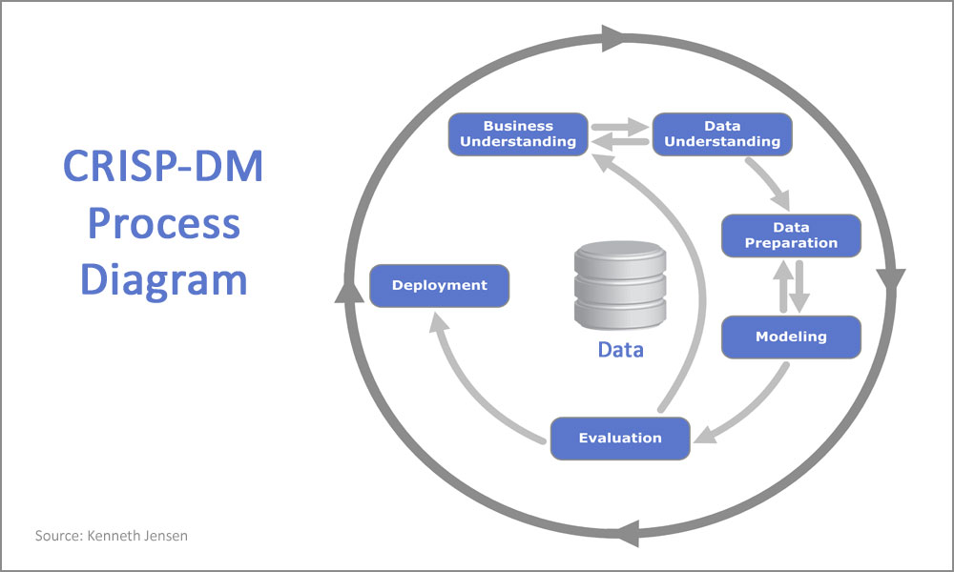

(“CRISP-DM still a leader in data mining models,” 2017)

Figure 3.1: CRISP-DM Methodology

**Software Used:**

**PYTHON:**Python is an [interpreted](https://en.wikipedia.org/wiki/Interpreted_language), [high-level](https://en.wikipedia.org/wiki/High-level_programming_language), [general-purpose](https://en.wikipedia.org/wiki/General-purpose_programming_language) [programming language](https://en.wikipedia.org/wiki/Programming_language). Python is [dynamically typed](https://en.wikipedia.org/wiki/Dynamic_programming_language) and [garbage-collected](https://en.wikipedia.org/wiki/Garbage_collection_(computer_science)). It supports multiple [programming paradigms](https://en.wikipedia.org/wiki/Programming_paradigm), including [procedural](https://en.wikipedia.org/wiki/Procedural_programming), object-oriented, and [functional programming](https://en.wikipedia.org/wiki/Functional_programming).It is highly extensible. It is one of the most demanding software in today’s IT world.(“Python (programming language),” 2019)The main libraries which have been used for the implementation of the research are mentioned below. They are:

Pandas: Pandas is a standard Python bundle for information science, and in light of current conditions: it offers unfathomable, expressive and adaptable information structures that make information control and assessment straightforward, among various things. The Data Frame is one of these structures. (“Pandas Tutorial,” 2019)

Tensor flow Keras: Keras is a high-level API to build and train deep learning models. It's utilized for quick prototyping, propelled research, and generation, with three key focal points:

Easy to understand: Keras has a basic, steady interface streamlined for normal use cases. It gives clear and significant criticism to client mistakes.

Measured and composable: Keras models are made by associating configurable structure squares together, with a couple of limitations.

Simple to broaden: Compose custom structure squares to express new thoughts for research. Make new layers, misfortune capacities, and create best in class models. (“Keras | TensorFlow Core,” n.d.)

**RAPID MINER:** RapidMiner is a data science platform for teams that unites data prep, machine learning, and predictive model deployment. It is one of the leading data science platforms. RapidMiner Studio is a visual workflow designer that makes data scientists more productive, from the rapid prototyping of ideas to designing mission-critical predictive models.(“Auto Model - RapidMiner Documentation,” n.d.) As per Gartner, Leaders should drive showcase change. They have the most elevated consolidated scores for Ability to Execute and Completeness of Vision. Highlights, for example, Auto Model, expanded investigation capacities, for example, Turbo Prep, and a better than expected UI make RapidMiner Studio a most loved of native information researchers. (“Gartner Magic Quadrant for Data Science Platforms,” n.d.)

**The following steps of the CRISP-DM Methodology where it explains each stage of the CRISP-DM process. The phases are:**

1. **Business Understanding**
2. **Data Understanding**
3. **Data Preparation**
4. **Modeling**
5. **Data Evaluation**
6. **Deployment**

**Each stage of the CRISP-DM method is explained below:**

**1.BUSINESS UNDERSTANDING:**

The concept that has been discussed above is the way Deep Convolutional Network can help in image classification. The physical edges of the garments are extremely difficult to be classified according to different patterns. This is because; many garments tend to same similar physical edges however; can have different textures and sizes. Therefore; in the case of manual classification, identification of exactly similar patterns and categories of the dresses is extremely difficult. Therefore, the concept of the Deep Convolutional Network helps in analyzing these minute patterns and helps in classifying the garments according to their different and unique features. In this regard, being a part of a deep learning technique, the Deep Convolutional Network is used to learn from similar designs and when the garments match with similar patterns, and then the system classifies those into the specific categories. This is the reason why this concept has become extremely beneficial for the fashion industry.

In many cases, a training set is formed, which helps in assessing the standards that would be required to follow in terms of classifying or identifying particular patterns of the garments. Therefore, when the concept of deep learning technique is used, then these training set is followed and then, the objectives are set to match the patterns with that training set. This is the process which significantly helps in gaining the high accuracy of image classification and the exact images are then classified. The overall process becomes beneficial for the organizations of the fashion industry and helps them to design and sell the garments efficiently to the customers. However; in many cases, the training set is not formed and then, the classification is made and tested according to the objectives that are made following the requirements of the industry. This process is challenging, however; helps the industry to gain a wide range of images and their classification. These classified images further help the industry to develop innovative designs of garments for the customers

**2. DATA UNDERSTANDING:**

Fashion MNIST is a dataset of Zalando's article pictures—comprising of a preparation set of 60,000 models and a test set of 10,000 models. Every model is a 28x28 grayscale picture, related to a mark from 10 classes. Zalando plans Fashion-MNIST to fill in as an immediate drop-in swap for the first MNIST dataset for benchmarking AI calculations. It has a similar picture size and structure of preparing and testing splits. The first MNIST dataset contains a ton of transcribed digits. Individuals from the AI/ML/Data Science people group love this dataset and use it as a benchmark to approve their calculations.

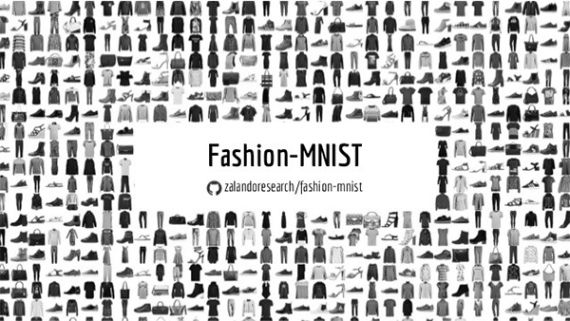

Figure 3.2: Fashion MNIST Dataset (“06.09.2017 Computer Science, Machine Learning & Statistiks Meetup - F…,” n.d.)

**3. DATA PREPARATION:** 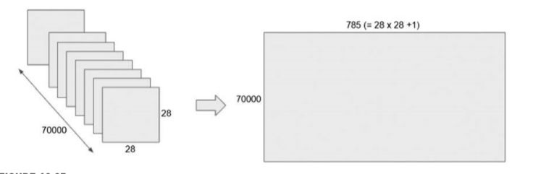

Figure 3.3: Data Preparation of Dataset

In the fashion MNIST dataset, the raw data comprises of 70,000 images which are 28×28 pixels. The model is executed in Python content. This should be changed into Pandas data frame which is of 70,000 rows (or samples) by 784 sections (pixel values) and after that split up into 60,000 sample training 10,000 sample test sets. The 28×28 (pixels) yields 784-pixel values. The principal administrator in this procedure is a Python content agent which takes the raw data and changes it. In the Execute python operator, the information is perused from the MNIST dataset, its shape spared, the pixel information changed into floats from integers lastly both preparing and test "x" and "y" vectors are unfurled and converged into Pandas data frames with the "y" section characterized as a name. The shape data is additionally returned as a data frame, with the goal that it can later be utilized to set picture sizes and shapes in convolution nets. The outcome from the execute python content comprises of three information outlines. They are:

* a training data frame 60,000 rows x 785 columns.
* Test data frame 10,000 x 785 columns.
* A shape data information outline which stores data about the information (each picture is 28 x 28 x 1 tensor, the 1 alludes to the channel)(Kotu and Deshpande, 2018)

**4. MODELING:**

In this stage, we mainly focus on selection and application of various modelling techniques. The different modelling techniques used here in this research are Python and Rapid miner. Using Python, we have implemented the convolution neural network keras TensorFlow and build the model for the improvement in the performance. We have also compared between traditional state-of-the-art traditional algorithms with H2O implemented deep learning algorithms using RapidMiner. The algorithms used are:

* Convolution Neural Network
* Naïve Bayes
* Support vector machine
* Deep Learning
* Logistic regression
* General Linearised Model
* Random Forest

***Convolution Neural Network:***

The name "convolutional neural system" demonstrates that the system utilizes a numerical activity called convolution. Convolution is a specific sort of direct activity. Convolutional systems are basically neural systems that utilization convolution instead of general lattice duplication in any event one of their layers. Convolutional neural systems are neuro-naturally propelled. A convolutional neural system comprises an input and an output layer, just as numerous hidden layers. The concealed layers of a CNN normally comprise of a progression of convolutional layers that convolve with increase or another speck item. The actuation capacity is generally a RELUlayer and is in this manner pursued by extra convolutions, for example, pooling layers, completely associated layers, and normalization layers alluded to as hidden layers in light of the fact that their data sources and outputs are veiled by the initiation capacity and last convolution. The last convolution, thusly, frequently includes backpropagation so as to all the more precisely weight the finished result.(“Convolutional neural network,” 2019)

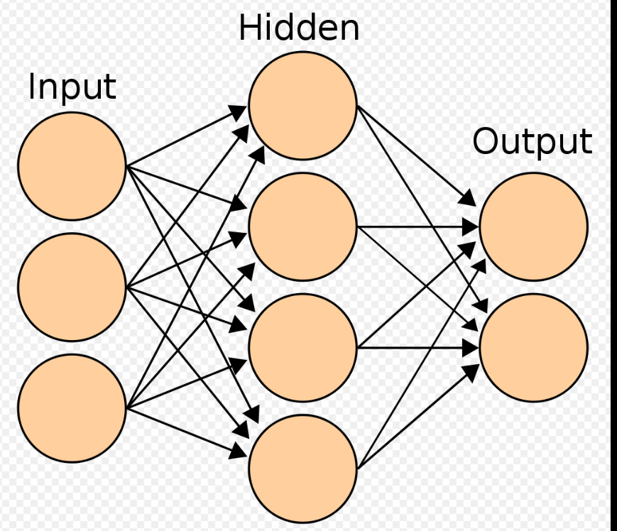

(en:User:Cburnett, 2006)

Figure 3.4: Convolution Neural Network

Firstly, we are going to train and test the data. To avoid overfitting of the model, we need to develop a proper evaluation dataset. Fitting the data into a training dataset and avoid the generalization. Once the training & testing and validate the data we need to put them into the deep learning network. Once this step was done, we had the array which was in the matrix form. We were supposed to re-shape the data i.e. [28 X 28 X 1] to form an image network. Importing Keras tensor flow which is an advanced package mainly used in deep learning the CNN architecture plays a huge role here in the modeling and refining them. We built a model basically with the convolution, the max-pooling layers, dense layer, flattening, drop-out and optimization where we used Adem optimizer. Convolution uses a kernel matrix (32) to scan a given image and apply a filter to obtain a certain effect. It preserves the spatial relationships between the pixels. In this the feature detector(where it will be 3 X 3 size) which is mentioned (32 X 3 X 3) and then specify the input shape of the image ( 28 X 28 X 1) with that the activation function ReLu. ReLu is a Rectified linear unit. They are used to add non-linearity in feature map. Make the image more spacious. Furthermost added the max-pooling layer which is also known as downsampling layer. This improves computational efficiency while preserving the features. It also helps the model to generalize by avoiding overfitting.The max pool size was (2 X 2). We flattened the network which makes one array and connects to fully connected neural network. Added the dense function and added the dimension (32) and the activation function ReLU. We also added the output layer, where we added the sigmoid function. Finally,we implemented the Adem optimizer for the proper optimization to find the accuracy and the epochs to know how many training datasets we see while updating the weights of each. To fit the CNN model, we used training data the value of epochs and the validation data.

***Naïve Bayes:***

It is a grouping system dependent on Bayes' Theorem with a supposition of opportunity among indicators. In clear terms, a Naive Bayes classifier expects that the closeness of a particular segment in a class is detached to the proximity of some other component. Close by straightforwardness, Naive Bayes is known to beat even astoundingly refined advanced order techniques. It rushes to foresee the class of the test informational collection. It similarly performs well in multi-class prediction. (“6 Easy Steps to Learn Naive Bayes Algorithm (with code in Python),” 2017)

The formula to explain the model is:

For all sections in the dataset, the denominator does not transform, it stays static. Accordingly, the denominator can be expelled and proportionality can be presented.(Gandhi, 2018)

***Logistic Regression:***

Logistic Regression is a Machine Learning calculation which is utilized for the classification problems, it is a prescient examination calculation and dependent on the concept of probability.(Pant, 2019)It is utilized to anticipate a double result (1/0, Yes/No, True/False) given a lot of independents variables.(“Simple Introduction to Logistic Regression in R,” 2015)

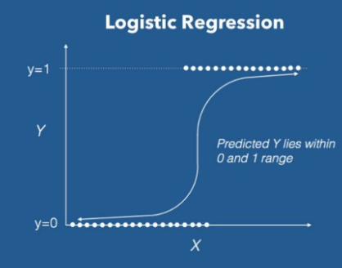

Figure 3.5: Working of Logistic Regression

***Support Vector Machine:***

In machine learning, support vector machines are supervised learning models with related learning calculations that break down information utilized for classification and regression analysis. Given a great deal of getting ready models, each set apart as having a spot with both of two classifications, an SVM planning computation makes a model that enables new advisers for one order or the other, making it a non-probabilistic parallel straight classifier. An SVM model is a representation of the models as focuses in space, mapped with the goal that the instances of the different classifications are partitioned by a reasonable hole that is as wide as would be prudent.(“Support-vector machine,” 2019)

***Generalized Linear Model:***

The term generalized linear model (GLM) as a rule refers to conventional linear regression models for a nonstop response variable given consistent and additionally absolute indicators. It incorporates numerous linear regression, just as ANOVA and ANCOVA (with fixed impacts as it were).(“6.1 - Introduction to Generalized Linear Models | STAT 504,” 2018)

***Random Forest:***

Random forests or random decision forests are an outfit learning strategy for order, relapse and different errands that work by developing a large number of choice trees at training time and outputting the class that is the method of the classes (classification) or mean prediction (regression) of the individual trees. Random decision forest right for choice trees' propensity for overfitting to their training set. (“Random forest - Wikipedia,” n.d.)Random forest resembles bootstrapping calculation with Decision tree (CART) model.(“Introduction To Random Forest simplified with a Case Study,” n.d.)

***Deep Learning:***

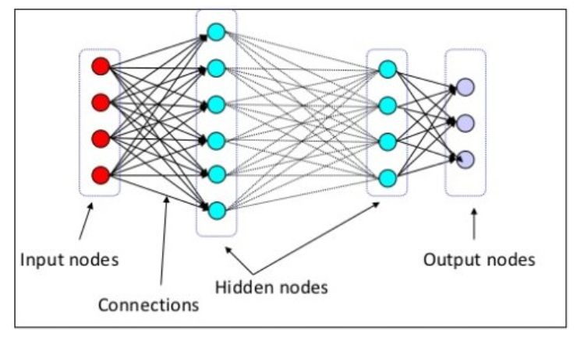

Figure 3.6: Architecture of Deep Learning(“Deep Learning Key Terms, Explained,” n.d.)

Deep learning is a particular subfield of machine learning: another interpretation of taking in portrayals from information that puts an accentuation on learning progressive layers of progressivelysignificantportrayals.(Chollet, 2018).

Deep Learning depends on a multi-layer feed-forward artificial neural system that is prepared with a stochastic gradient boosting plunge utilizing back-proliferation. The system can contain countless concealed layers comprising of neurons with tanh, rectifier, and maxout activation functions Propelled highlights, for example, versatile learning rate, rate strengthening, momentum training, dropout, and L1 or L2 regularization empower high prescient exactness. Each compute node prepares a duplicate of the global model parameters on its nearby information with multi-stringing (asynchronously), and contributes occasionally to the global model by means of model averaging over the network. (“RapidMiner Documentation,” n.d.)The Deep Learning approach is some of the time called all inclusive learning since it very well may be connected to nearly anyapplication domain. Deep learning methodologies don't require the unequivocally planned element. Rather, optimalfeatures are naturally learned for the job that needs to be done. Subsequently, the robustness to the naturalvariations of the information is achieved. The Deep Learning approach is profoundly versatile. We have likewise utilized H20 actualized deep learning calculations in the quick excavator the main information platform to think about the precision and enhance the presentation of the model.

Deep Learning in H2O is actualized locally as a Multi-Layer Perceptron (MLP). Yet, H2O additionally enables us to construct autoencoders (an autoencoder is a neural net that takes a lot of information sources, packs and encodes them, and afterward attempts to recreate the contribution as precisely as could reasonably be expected). Repetitive Neural Networks and Convolutional Neural Networks can be built utilizing H2O's Deep Water Project through outsider incorporations of other Deep Learning libraries, for example, Caffe and TensorFlow. The client needs to determine the estimations of the hyper-parameters of the Deep Learning model. Parameters allude to the loads and predispositions of a profound learning model. Hyper-parameters are the alternatives one needs to plan a neural net, similar to various layers, hubs per layer, actuation, the decision of regularizer, among others. The calculations of the worldwide model parameters can be kept running on a solitary hub or a multi-hub group. For a multi-hub group, a duplicate of the worldwide model parameters is prepared on the neighborhood information of a registered hub, through multi-strung and appropriated parallel calculation. The model arrives at the midpoint of over the system with each process hub contributing intermittently to the global model.(“Deep Learning in H2O using R,” 2018)

**5. EVALUATION:**

In this phase, we are evaluating the results obtained from the models.

* **Confusion Matrix:**

A confusion matrix is a summary of expectation results on a classification problem. The quantity of right and mistaken forecasts is outlined with check esteems and separated by each class. This is the way to the confusion matrix. The confusion matrix demonstrates the manners by which the classification model is confused when it makes predictions. It gives us knowledge not just into the blunders being made by a classifier yet more significantly the sorts of errors that are being made.(“Confusion Matrix in Machine Learning - GeeksforGeeks,” n.d.)

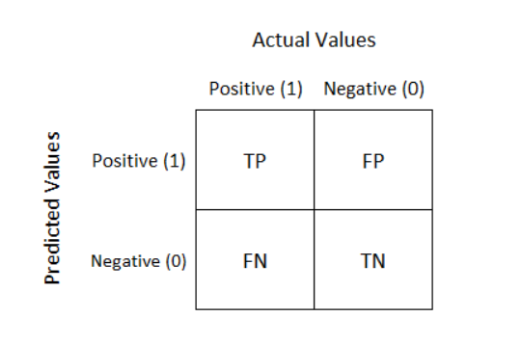

(“Understanding Confusion Matrix - Towards Data Science,” n.d.)

Definition of the Terms:

Positive(P): Perception is positive.

Negative(N): Perception is not positive

True Positive (TP): Perception is positive and anticipated as Negative.

True Negative (TN): Perception is negative and anticipated as positive.

False Positive (FP): Perception is negative and anticipated as positive.

False Negative (FN): Perception is positive and anticipated as negative.

* **Class Recall:**

Recall can be defined as the proportion of the all outnumber of accurately ordered positive examples divide to the total number of positive models. High Recall demonstrates the class is accurately perceived (small number of FN).

It is given by the equation:

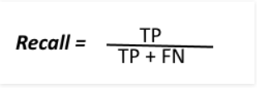

* **Class Precision:**

To get the estimation of accuracy we partition the complete number of effectively ordered positive models by the all-out number of anticipated positive models. High Accuracy shows a model marked as positive is for sure positive (modest number of FP).

It is calculated by the equation:

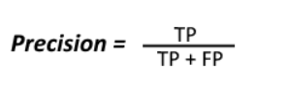

**6. Deployment:**

In this phase, researcher will spread out the data and arrange them advantageously and present them in a manner that Business can utilize it. This incorporates utilizing the models made to help the executive procedure of the association.(“What is deploy? - Definition from WhatIs.com,” n.d.)

In this particular research, the deployment stage is anImplement the classifier using Python Flask to test classification on its image garment samples. Flask is a smaller scale web structure written in Python. It is named a microframework on the grounds that it doesn't require specific apparatuses or libraries. It has no database reflection layer, structure approval, or whatever other segments where prior outsider libraries give regular capacities. Notwithstanding, Flask's underpins extensions that can include application includes as though they were actualized in Flask itself. Extensions exist for item social mappers, structure approval, transfer taking care of, different open validation innovations and a few regular system-related tools. (“Flask (web framework) - Wikipedia,” n.d.). A Web structure is an accumulation of bundles or modules which enable engineers to compose Web applications (see WebApplications) or administrations without taking care of such low-level subtleties as conventions, attachments or procedure/string the board.(“WebFrameworks - Python Wiki,” n.d.) . The future deployment would be a virtual assistant tool for each fashion industry that compares traditional machine learning and state of the art deep learning algorithms for image classification.

**Chapter 4-**

**RESULTS AND DISCUSSION:**

* **MODEL RESULT IN PYTHON:**

In the below output, it shows that we have picked 25 images where we have created a grid of 5 x 5. Once the code is done the purpose is to reshape the image to the format of 28 X 28 pixels. We need to witness thatpredicted class value should be same equal to the true class. The obtained result is attached below:

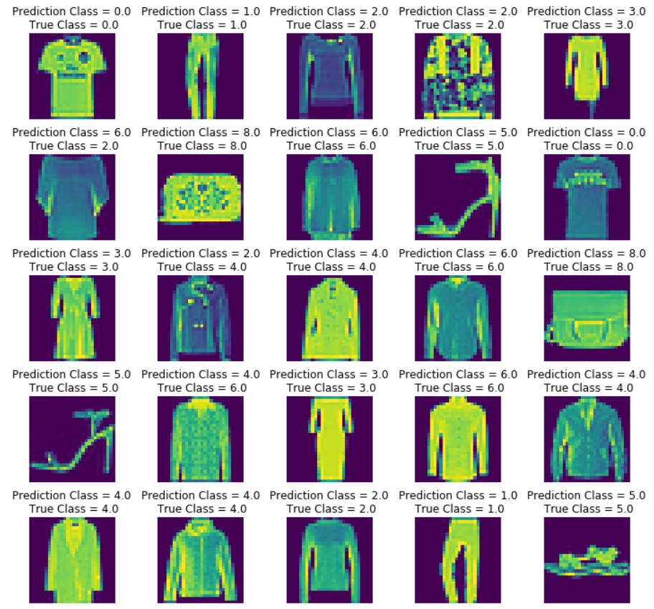

Figure 4.1: Grid matrix performance of a classification model

A confusion matrix is a summary of expectation results on a classification problem. The quantity of right and mistaken forecasts is outlined with check esteems and separated by each class. (“Confusion Matrix in Machine Learning - GeeksforGeeks,” n.d.).All the rows showing the predicted values and the rest is the true value. A lot of samples which have been classified accurately. Gives a overview overall how the classes has been classified.

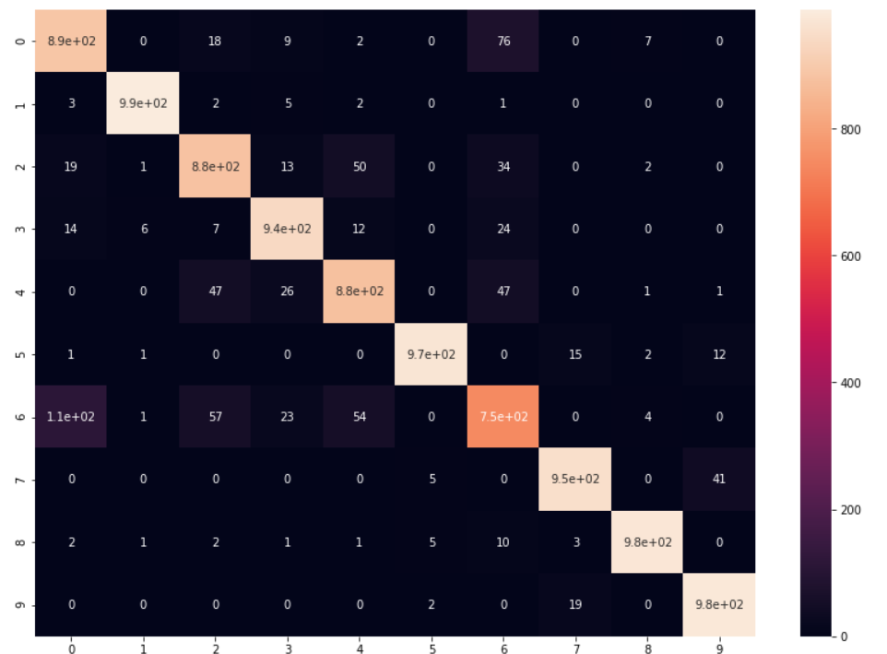

*Figure 4.2: Confusion Matrix*

In the below output, the number of classes mentioned is 10 from where it has been noticed that this is the method to generate the report. It can be configured for the number of classes of our choice. In our case we generated report for all the classes i.e. prediction classes is the variable which holds value for the output class which would be compared with the test output which holds the actual output class for the prediction. As observed in the output report for each class is displayed with the important parameter specifications such as precision, recall, and support. Support is seen to same for all classes. In terms of precision and recall, class 1 is most accurately predicted. The overall result obtained was 94%

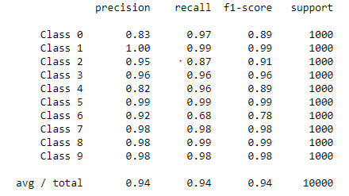

Figure 4.3: Evaluation of Model

* **MODEL RESULTS IN RAPID MINER**

To analyse the presentation of best in class traditional algorithms with H2O executed deep learning calculations utilizing RapidMiner. In the below tabular column, we have executed the various traditional algorithms such as Logistic regression, deep learning, Naïve Bayes, General Linear Model, Random forest, and Support vector machine. The output which was achieved in high was found to be the deep learning with 87.2% with the run time of 3.13 minutes which is prohibitive compared to rest of the traditional algorithms.

|  |  |  |  |  |  |
| --- | --- | --- | --- | --- | --- |
| **Model** | **Accuracy** | **Standard Deviation** | **Total time** | **Training time (1000 Rows)** | **Scoring time (1000 Rows)** |
| **Logistic Regression** | **83.6%** | **±0.3%** | **1:01:58** | **11s** | **359ms** |
| **Deep Learning** | **87.2%** | **±0.4%** | **3:13** | **4s** | **74ms** |
| **Naïve Bayes** | **66.1%** | **±0.6%** | **34s** | **36ms** | **79ms** |
| **General Linear Model** | **85.5%** | **±0.4%** | **24:16** | **40s** | **45ms** |
| **Random Forest**  **Support Vector Machine** | **71.7%**  **33.7%** | **±0.5%**  **±1.5%** | **2:52:37**  **1:46:31** | **23s**  **31s** | **434ms**  **18s** |

*Table 4.1: Model Result in Rapid Miner*

***SCREENSHOTS OF THE RESULTS OBTAINED IN RAPID MINER***:

1. **DEEP LEARNING**

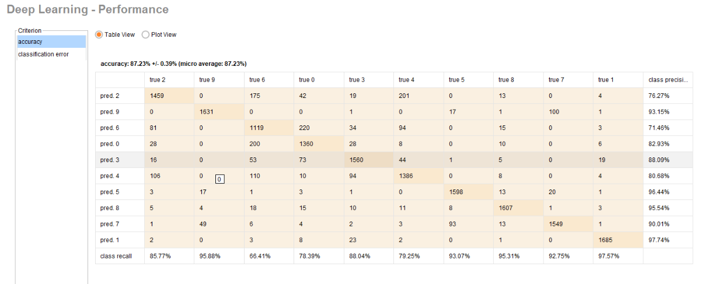

*Figure 4.4: Confusion Matrix Deep Learning*

From the above confusion matrix, it has been seen that the accuracy was found to be 87.23%

1. **LOGISTIC REGRESSION PERFORMANCE:**

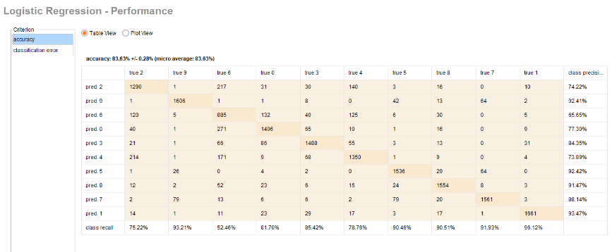

*Figure 4.5: Confusion Matrix Logistic Regression*

The results obtained from this model, was quite good performance with the accuracy of 83.6%

1. **GENERALISED LINEAR MODEL:**

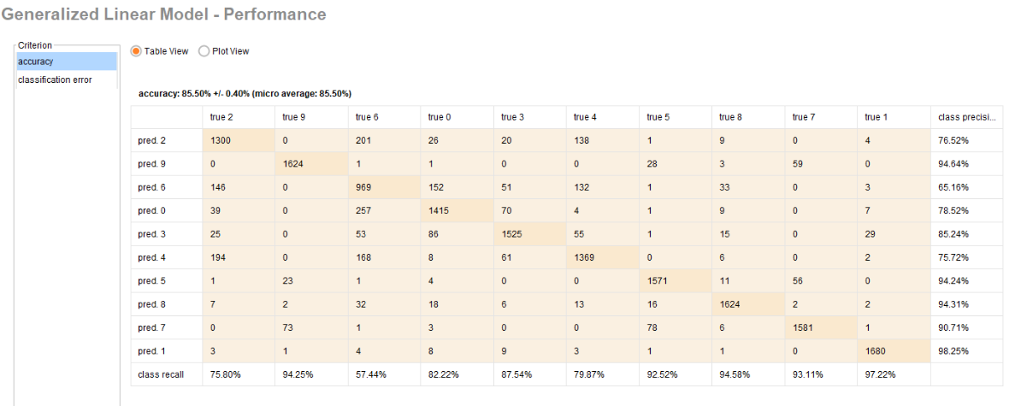

*Figure 4.6: Confusion Matrix GLM*

From the above results achieved, GLM has reached its maximum level by proving the accuracy of 85.50% which was virtually near to the Deep learning.

1. **NAÏVE BAYES:**

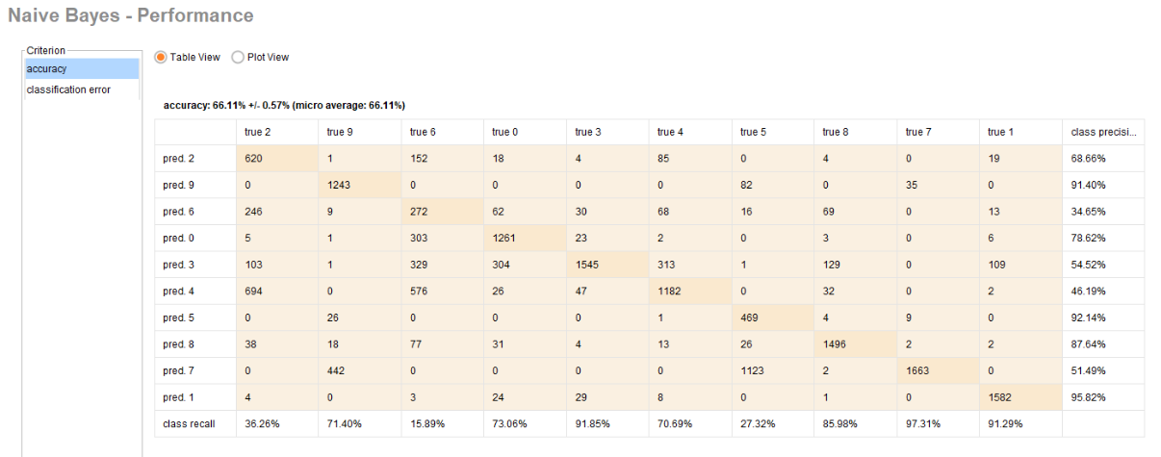

*Figure 4.7: Confusion Matrix Naïve Bayes*

From the above results achieved, the overall accuracy was found to be 66.11% in a very less time of 34s.

1. **RANDOM FOREST**

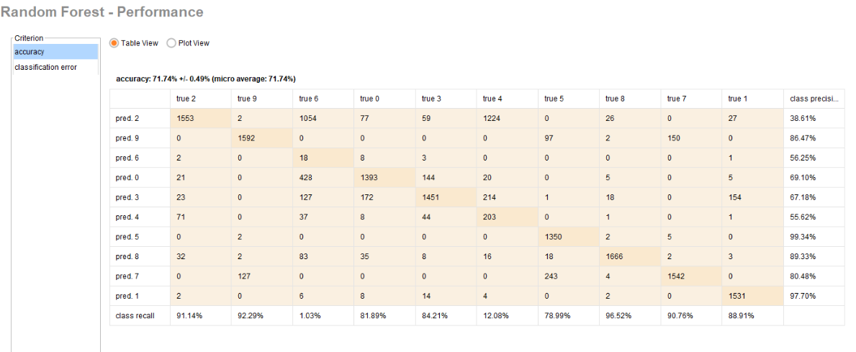

*Figure 4.8: Confusion Matrix Random Forest*

The accuracy obtained from this model was found to be 71.1%.

1. **SUPPORT VECTOR MACHINE**

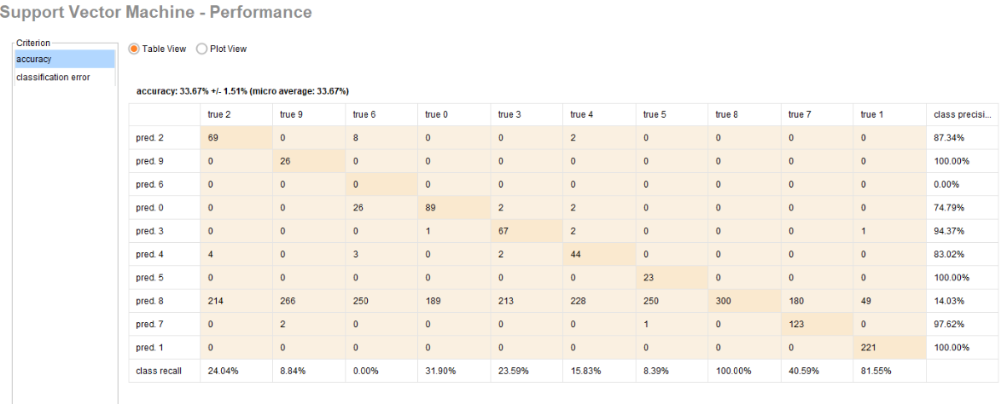

*Figure 4.9: Confusion Matrix SVM*

From the above output, what we observed was the result which we got from the support vector machine was found to be very less percentage which was of 33.67% which has got the least percentage of accuracy and seems to be not a perfect match.

**Comparison of the Algorithm:**

Overall, the results which was achieved from both Python and H20 deep learning what we originated was the implementation of the model got the better result(93.8% in Jupyter python notebook where we have used Keras tensorflow CNN algorithm comparatively to the traditional algorithms where we used Rapid miner deep learning H20 algorithms to run the models and find the accuracy where we got 87.2%.

* **RESULT OBTAINED USING THE CLASSIFIER FLASK IN PYTHON:**







*Figure 4.10: Web page predicting the class image bag*

The output which has obtained in the html page gives a brief idea about the flask which we implemented in Python jupyter notebook has predicted the value of the class labels accurately. In the above image if we observe, we have a chosen a image of the bag and the result which it has predicted correctly. Overall, applying the classifier using Python Flask to try-out the classification on its image garment samples worked satisfactory for the images.



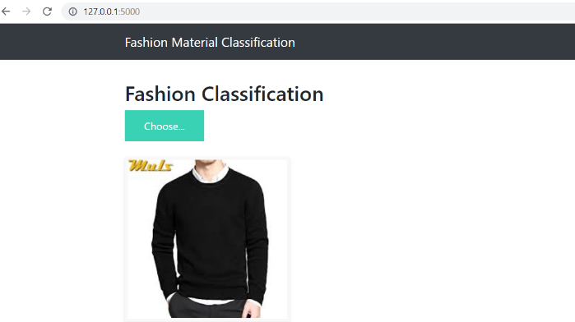

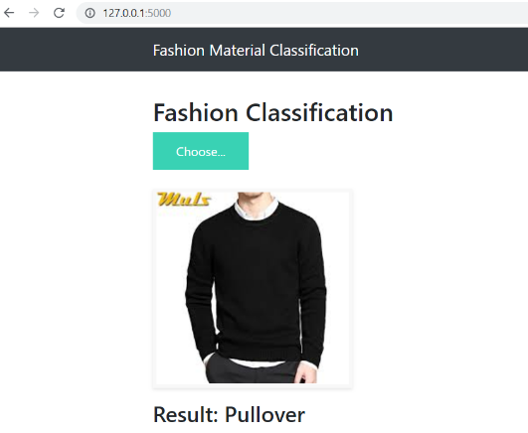

*Figure 4.10: Web page predicting the class image bag*

The output which has obtained in the html page gives a brief idea about the flask which we implemented in Python jupyter notebook has predicted the value of the class labels accurately. In the above image if we observe, we have a chosen a image of the pullover and the result which it has predicted correctly. Overall, applying the classifier using Python Flask to try-out the classification on its image garment samples worked satisfactory for the images.

**Chapter 5:**

**CONCLUSION & FUTURE WORKS:**

In this research work, we have made the comparative study about the functioning of traditional machine learning algorithms with the state art of deep algorithms for the concept of image classification.The Fashion-MNIST dataset which has 60,000 training and 10,000 testing data. From the algorithms which have been executed, the simulation results proved that Convolution neural network is the best fit and one of the ways to build an efficient model and hence the deep learning will outperform traditional methods with the optimal performance which was accomplished by the Keras tensorflow. On the other side, while implementing the models in Rapid miner we observed that the run time of the models were taking long time to run by giving the less amount of accuracy which was one of the disadvantages observed. The major accuracy obtained in the rapid miner; the deep learning algorithm performance was better compared to all other models. Meanwhile, the Keras tensorflow, a proper fitting algorithm CNN which was written in the jupyter notebook and the performance of that model was found to be exceptional and gave the appropriate result.

In the final stage we implemented the classifier using Python flask which gave us the predicted answer to the image we uploaded in the html file. As there are ten classes in the label, it has been categorised and the image which we upload was expecting the answer correctly. From this we can also prove that our research question has been answered and proving state of an art deep learning algorithms have more accurate performance when compared to traditional ones.

**Future Works:**

Fashion Industry nearly has 2% of the worlds GDP and it is expected to continues to be in a high position as there no decline in the people who are into this as there are new trends, challenges and wide opportunities. This fashion industry is an eternal and it never fades. This research would be an area of scope as a part of future work in predicting the performance to image classification using the state of art deep learning algorithm for different categories of the fashion industry which will be a huge success if it works out as it will be more easier for the people to access the industry items without having any mess or accessing it in lesser time when compared to existing models.

# Chapter 6-

# References:

Al-Halah, Z., Stiefelhagen, R., Grauman, K., 2017. Fashion Forward: Forecasting Visual Style in Fashion, in 2017 IEEE International Conference on Computer Vision (ICCV). Presented at the 2017 IEEE International Conference on Computer Vision (ICCV), IEEE, Venice, pp. 388–397. <https://doi.org/10.1109/ICCV.2017.50>

Brito, P.Q., Soares, C., Almeida, S., Monte, A., Byvoet, M., 2015. Customer segmentation in a large database of an online customized fashion business. Robot. Comput.-Integr. Manuf. 36, 93–100. <https://doi.org/10.1016/j.rcim.2014.12.014>

Chollet, F., 2017. Xception: Deep Learning with Depthwise Separable Convolutions, in: 2017 IEEE Conference on Computer Vision and Pattern Recognition (CVPR). Presented at the 2017 IEEE Conference on Computer Vision and Pattern Recognition (CVPR), IEEE, Honolulu, HI, pp. 1800–1807. <https://doi.org/10.1109/CVPR.2017.195>

Corona, E., Alenyà, G., Gabas, A., Torras, C., 2018. Active garment recognition and target grasping point detection using deep learning. Pattern Recognit. 74, 629–641. <https://doi.org/10.1016/j.patcog.2017.09.042>

Date, P., Ganesan, A., Oates, T., 2017. Fashioning with Networks: Neural Style Transfer to Design Clothes. ArXiv170709899 Cs.

De Oliveira, D.C., Wehrmeister, M.A., 2018. Using Deep Learning and Low-Cost RGB and Thermal Cameras to Detect Pedestrians in Aerial Images Captured by Multirotor UAV. Sensors 18, 2244. <https://doi.org/10.3390/s18072244>

Gupta, S., 2015. Apparel Classifier and Recommender using Deep Learning Live Demo.

Hara, K., Jagadeesh, V., Piramuthu, R., 2016. Fashion Apparel Detection: The Role of Deep Convolutional Neural Network and Pose-dependent Priors. 2016 IEEE Winter Conf. Appl. Comput. Vis. WACV 1–9. <https://doi.org/10.1109/WACV.2016.7477611>

Hohman, F., Kahng, M., Pienta, R., Chau, D.H., 2018. Visual Analytics in Deep Learning: An Interrogative Survey for the Next Frontiers. ArXiv180106889 Cs Stat.

Islam, S.M.S., Dey, E.K., Tawhid, Md.N.A., Hossain, B.M.M., 2017. A CNN Based Approach for Garments Texture Design Classification. Adv. Technol. Innov. 2, 119–125.

Li, O., Liu, H., Chen, C., Rudin, C., n.d. Deep Learning for Case-Based Reasoning through Prototypes: A Neural Network that Explains Its Predictions 8.

Li, Y., Cao, L., Zhu, J., Luo, J., 2017. Mining Fashion Outfit Composition Using An End-to-End Deep Learning Approach on Set Data. IEEE Trans. Multimed. 19, 1946–1955. <https://doi.org/10.1109/TMM.2017.2690144>

Lin, K., Yang, huei-fang, Hsiao, jen-hao, liu, kuan-hsien, chen, chu-song, 2015. Rapid Clothing Retrieval via Deep Learning of Binary Codes and Hierarchical Search. Int. Conf. Multimed. Retr. 409–502. <https://doi.org/10.1145/2671188.2749318>

Liu, Z., Luo, P., Qiu, S., Wang, X., Tang, X., 2016. DeepFashion: Powering Robust Clothes Recognition and Retrieval with Rich Annotations, in: 2016 IEEE Conference on Computer Vision and Pattern Recognition (CVPR). Presented at the 2016 IEEE Conference on Computer Vision and Pattern Recognition (CVPR), IEEE, Las Vegas, NV, USA, pp. 1096–1104. <https://doi.org/10.1109/CVPR.2016.124>

Marcus, G., 2018. Deep Learning: A Critical Appraisal.

Mariolis, I., Peleka, G., Kargakos, A., Malassiotis, S., 2015. Pose and category recognition of highly deformable objects using deep learning, in 2015 International Conference on Advanced Robotics (ICAR). Presented at the 2015 International Conference on Advanced Robotics (ICAR), IEEE, Istanbul, Turkey, pp. 655–662. <https://doi.org/10.1109/ICAR.2015.7251526>

Ngo, C.J., Desnoyers, M.D., Wutka, S.E., 2017. Stripped Down: A Look into the Sustainability of Hong Kong’s Fashion Industry 102.

Piazza, A., Zagel, C., Huber, S., Hille, M., Bodendorf, F., 2015. Outfit Browser – An Image-data-driven User Interface for Self-service Systems in Fashion Stores. Procedia Manuf. 3, 3521–3528. <https://doi.org/10.1016/j.promfg.2015.07.686>

Rostamzadeh, N., Hosseini, S., Boquet, T., Stokowiec, W., Zhang, Y., Jauvin, C., Pal, C., 2018. Fashion-Gen: The Generative Fashion Dataset and Challenge. ArXiv180608317 Cs Stat.

Shah, N.P., Hanchate, D.B., 2018. Fashion Outfit Composition by Deep Learning Approach 05, 8.

Sun, Y., Xue, B., Zhang, M., Yen, G.G., 2017. Evolving Deep Convolutional Neural Networks for Image Classification. ArXiv171010741 Cs.

Tangseng, P., Wu, Z., Yamaguchi, K., 2017. Looking at Outfit to Parse Clothing. ArXiv170301386 Cs.

T.L. Chan, A., W.T. Ngai, E., Moon, K.K.L., 2016. The Effects of Strategic and Manufacturing Flexibilities and Supply Chain Agility on Firm Performance in the Fashion Industry. Eur. J. Oper. Res. <https://doi.org/10.1016/j.ejor.2016.11.006>

Tuinhof, H., Pirker, C., Haltmeier, M., 2019. Image Based Fashion Product Recommendation with Deep Learning. ArXiv180508694 Cs 11331, 472–481. <https://doi.org/10.1007/978-3-030-13709-0_40>

Vidgen, R., Shaw, S., Grant, D.B., 2017. Management challenges in creating value from business analytics. Eur. J. Oper. Res. 261, 626–639. <https://doi.org/10.1016/j.ejor.2017.02.023>

Wang, J., Mall, S., Perez, L., 2017. The Effectiveness of Data Augmentation in Image Classiﬁcation using Deep Learning 8.

Wu, R., Yan, S., Shan, Y., Dang, Q., Sun, G., 2015. Deep Image: Scaling up Image Recognition. Baidu Res.

Xie, S., Tu, Z., n.d. Holistically-Nested Edge Detection 9.

Zintgraf, L.M., Cohen, T.S., Adel, T., Welling, M., 2017. Visualizing Deep Neural Network Decisions: Prediction Difference Analysis. ArXiv170204595 Cs.

Learn Naive Bayes Algorithm (with code in Python), 2017. . Analytics Vidhya. URL https://www.analyticsvidhya.com/blog/2017/09/naive-bayes-explained/ (accessed 8.20.19).

Convolutional neural network, 2019. . Wikipedia.

Decision tree, 2019. . Wikipedia.

Gandhi, R., 2018. Naive Bayes Classifier [WWW Document]. Medium. URL https://towardsdatascience.com/naive-bayes-classifier-81d512f50a7c (accessed 8.20.19).

Keras | TensorFlow Core [WWW Document], n.d. . TensorFlow. URL https://www.tensorflow.org/guide/keras (accessed 8.20.19).

Kotu, V., Deshpande, B., 2018. Data Science: Concepts and Practice. Morgan Kaufmann.

Mady ), M.S.(, 2018. Chapter 4: Decision Trees Algorithms [WWW Document]. Medium. URL https://medium.com/deep-math-machine-learning-ai/chapter-4-decision-trees-algorithms-b93975f7a1f1 (accessed 8.20.19).

Pandas Tutorial: DataFrames in Python [WWW Document], 2019. .DataCamp Community. URL https://www.datacamp.com/community/tutorials/pandas-tutorial-dataframe-python (accessed 8.20.19).

Pant, A., 2019. Introduction to Logistic Regression [WWW Document]. Medium. URL https://towardsdatascience.com/introduction-to-logistic-regression-66248243c148 (accessed 8.20.19).

Simple Introduction to Logistic Regression in R, 2015. . Analytics Vidhya. URL https://www.analyticsvidhya.com/blog/2015/11/beginners-guide-on-logistic-regression-in-r/ (accessed 8.20.19)..

Support-vector machine, 2019. . Wikipedia.

Swaminathan, S., 2019. Linear Regression — Detailed View [WWW Document]. Medium. URL https://towardsdatascience.com/linear-regression-detailed-view-ea73175f6e86 (accessed 8.20.19).

Wirth, R. (2013) ‘CRISP-DM: Towards a standard process model for data mining’, in Proceedings of the Fourth International Conference on the Practical Application of Knowledge Discovery and Data Mining, pp. 29–39.

6 Easy Steps to Learn Naive Bayes Algorithm (with code in Python), 2017. . Analytics Vidhya. URL https://www.analyticsvidhya.com/blog/2017/09/naive-bayes-explained/ (accessed 8.20.19).

* 1. - Introduction to Generalized Linear Models | STAT 504 [WWW Document], 2018. URL https://newonlinecourses.science.psu.edu/stat504/node/216/ (accessed 8.26.19).

06.09.2017 Computer Science, Machine Learning & Statistiks Meetup - F… [WWW Document], n.d. URL https://www.slideshare.net/Zalando-adtech-lab/06092017-computer-science-machine-learning-statistiks-meetup-fashionmnist (accessed 8.26.19).

50 Famous Quotes from Fashion Icons - Famous Fashion Quotes From Designers [WWW Document], n.d. URL https://www.harpersbazaar.com/fashion/designers/a1576/50-famous-fashion-quotes/ (accessed 8.26.19).

Chollet, F., 2018. Deep learning with Python. Manning Publications Co, Shelter Island, New York.

Confusion Matrix in Machine Learning - GeeksforGeeks [WWW Document], n.d. URL https://www.geeksforgeeks.org/confusion-matrix-machine-learning/ (accessed 8.26.19).

Convolutional neural network, 2019. . Wikipedia.

Decision tree, 2019. . Wikipedia.

Deep Learning in H2O using R [WWW Document], 2018. URL https://www.kdnuggets.com/2018/01/deep-learning-h2o-using-r.html (accessed 8.26.19).

Deep Learning Key Terms, Explained [WWW Document], n.d. URL https://www.kdnuggets.com/2016/10/deep-learning-key-terms-explained.html (accessed 8.26.19).

Flask (web framework) - Wikipedia [WWW Document], n.d. URL https://en.wikipedia.org/wiki/Flask_(web_framework) (accessed 8.26.19).

Gandhi, R., 2018. Naive Bayes Classifier [WWW Document]. Medium. URL https://towardsdatascience.com/naive-bayes-classifier-81d512f50a7c (accessed 8.20.19).

Keras | TensorFlow Core [WWW Document], n.d. . TensorFlow. URL https://www.tensorflow.org/guide/keras (accessed 8.20.19).

Kotu, V., Deshpande, B., 2018. Data Science: Concepts and Practice. Morgan Kaufmann.

Mady ), M.S.(, 2018. Chapter 4: Decision Trees Algorithms [WWW Document]. Medium. URL https://medium.com/deep-math-machine-learning-ai/chapter-4-decision-trees-algorithms-b93975f7a1f1 (accessed 8.20.19).

Pandas Tutorial: DataFrames in Python [WWW Document], 2019. . DataCamp Community. URL https://www.datacamp.com/community/tutorials/pandas-tutorial-dataframe-python (accessed 8.20.19).

Pant, A., 2019. Introduction to Logistic Regression [WWW Document]. Medium. URL https://towardsdatascience.com/introduction-to-logistic-regression-66248243c148 (accessed 8.20.19).

RapidMiner Documentation [WWW Document], n.d. URL https://docs.rapidminer.com/latest/studio/operators/modeling/predictive/neural_nets/deep_learning.html. (accessed 8.26.19).

Simple Introduction to Logistic Regression in R, 2015. . Analytics Vidhya. URL https://www.analyticsvidhya.com/blog/2015/11/beginners-guide-on-logistic-regression-in-r/ (accessed 8.20.19).

Support-vector machine, 2019. . Wikipedia.

WebFrameworks - Python Wiki [WWW Document], n.d. URL https://wiki.python.org/moin/WebFrameworks (accessed 8.26.19).

What is deploy? - Definition from WhatIs.com [WWW Document], n.d. URL https://whatis.techtarget.com/definition/deploy (accessed 8.26.19).

Piras, L. and Giacinto, G., 2017. Information fusion in content based image retrieval: A comprehensive overview. Information Fusion, 37, pp.50-60.<http://pralab.diee.unica.it/sites/default/files/Information%20Fusion%20in%20Content%20Based%20Image%20Retrieval-A%20Comprehensive%20Overview.pdf>

Sun, Y., et al.(2019). ‘Evolving deep convolutional neural networks for image classification.’ IEEE Transactions on Evolutionary Computation.<https://arxiv.org/pdf/1710.10741>

Zhang, X., 2018. An Improved Method of Identifying Mislabeled Data and the Mislabeled Data in MNIST and CIFAR-10 Appendix Findings in Fashion-MNIST. Available at SSRN 3097307.<https://papers.ssrn.com/sol3/papers.cfm?abstract_id=3097307>

**Chapter-7:**

**Appendices:**

This section gives a brief understanding about the information which is presented in the

Artefact and the essential steps which has been followed in Jupyter python notebook and the

implementation of the H20 deep learning in python.

CONTENTS ATTACHED IN THE ARTEFACT:

1. Dataset:

Training data: Consists of 60,000 examples(fashion-mnist_train.csv)

Testing data: Consists of 10,000 examples. (fashion-mnist_test.csv)

2. Python Code:

Primary code: The CNN model using tensorflow keras.

Secondary code: Implementation of the flask in python and the code and input and

output of the process is attached

3. Rapid Miner:

Models Executed: Deep learning, Support vector machine, Random forest, Logistic

regression, Naïve Bayes, General Linear model.

Results saved: All the process executed and the results are attached in .rmp file

4. Readme:

Explains how the code has been implemented in Python and gives a brief idea about

the process executed in Rapid miner.